**Create Power BI visuals using R**

With Power BI Desktop, you can use R to visualize your data. R is a language and environment for statistical computing and graphics.

<https://mran.revolutionanalytics.com/documents/what-is-r>

**Install R**

By default, Power BI Desktop doesn't include, deploy, or install the R engine. To run R scripts in Power BI Desktop, you must separately install R on your local computer.

<https://mran.revolutionanalytics.com/download/>

<https://cran.r-project.org/bin/windows/base/>

**Enable R visuals in Power BI Desktop**

After you've installed R, Power BI Desktop enables it automatically. To verify that Power BI Desktop has enabled R in the correct location, follow these steps:

1. From the Power BI Desktop menu, select **File** > **Options and settings** > **Options**.
2. On the left side of the **Options** page, under **Global**, select **R scripting**.
3. Under **R script options**, verify that your local R installation is specified in **Detected R home directories** and that it properly reflects the local R installation you want Power BI Desktop to use. In the following image, the path to the local installation of R is **C:\Program Files\R Open\R-4.0.2\**

**Create R visuals in Power BI Desktop**

1. Select the **R Visual** icon in the **Visualization** pane to add an R visual.

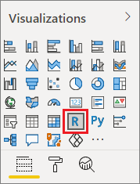

1. In the **Enable script visuals** window that appears, select **Enable**.

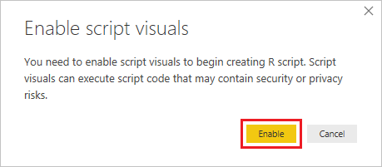

When you add an R visual to a report, Power BI Desktop makes the following changes:

A placeholder R visual image appears on the report canvas.

The **R script editor** appears along the bottom of the center pane.

